**CAR DEKHO**

**INTRODUCTION**

This data set contains vehicle details in car dekho website and includes information of vehicles such as name of the vehicle, year of purchase, selling_price, km_driven,, fuel type, seller_type, transmission type, owner type, mileage of the vehicle, engine power, max_power, torque, number of seats.

To easily find and classify vehicles to the users.

**AIM**

The main goal is to find, classify and easily access data of vehicles which can help customers and users. This database contain important data about all car in car dekho website.

**OBJECTIVE**

1.Data collection

By analysing this database, this database includes all important details about available vehicles. The data was stored in relational database.

2.Data cleaning

The database contains many missing values and duplicate rows, by the cleaning process we can ensure the database integrity.

3.SQL Queries

This database includes SQL queries to execute relevant information by using SELECT, WHERE, DISTINCT, LIMIT, GROUP BY, ORDER BY, and aggregation functions.

**DATA OVERVIEW**

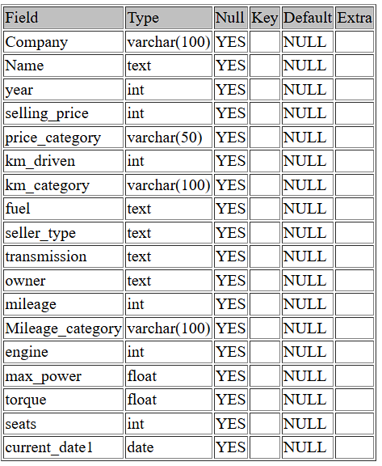

**QUESTIONS**

1.To find the total number of vehicles.

select count(*) from car_table;

7927

2. Categorize the column transmission with number of vehicle.

select transmission,count(*) from car_table3 group by transmission;

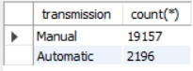

3. Categorize the column seats with number of vehicle.

select seats,count(*) from car_table3 group by seats;

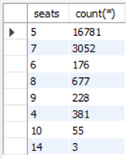

4. Categorize the column owner with number of vehicle.

select owner,count(*) from car_table3 group by owner;

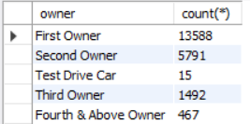

5. Find all details of top ten driven vehicles.

select * from car_table3 order by km_driven desc limit 10;

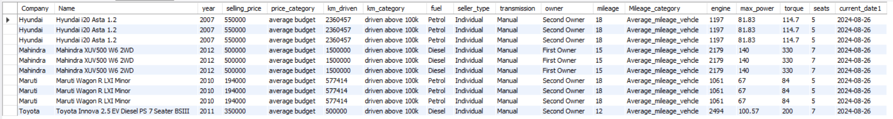

6 Find the number of vehicles with selling price below 1 lakh.

select * from car_table3 where selling_price<100000 order by selling_price;

809

7. Find the number of first owner vehicles.

select count(*) from car_table3 where owner="First Owner" order by selling_price;

1358

8. Vehicle with high mileage.

select * from car_table3 where mileage order by mileage desc limit 1;

Volvo XC90 T8 Excellence BSIV

9. Find premium cars in the table.

select * from car_table3 where price_category="premium vehcle";

10. Find the number of Maruti cars.

select count(*) from car_table3 where Name like "Maruti%";

11. Find the number of vehicles driven below 10000 kilometer.

select count(*) from car_table3 where km_category="driven below 10k";

879

12. Average selling price of vehicles with low, average and high mileage.

select Mileage_category,avg(selling_price) from car_table3 group by Mileage_category;

|  |  |
| --- | --- |
| Average_mileage_vehicle | = 592767.0001 |
| High_mileage_vehicle | = 531423.9634 |
| Low_ mileage_vehicle | = 1090338.5354 |
|  |  |
| 13. Find vehicles with year before 2000.  select * from car_table3 where year<2000; |  |

**CONCLUSION**

1.Total number of vehicles.

- The total number of vehicles in the database car_dekho is 7927.

2.Total number of companies.

- The total number of companies in the database is 32.

3.The most of the vehicle in the company.

- Maruti company is the most vehicles in the database.

4.Number of manual and automatic vehicles in transmission category.

- Manual = 6879

- Automatic = 1048

5. Which seater vehicle is most in the database.

- 5 seater vehicle.

6.Most driven vehicle.

- Hyundai i20 Asta 1.2 is the most driven vehicle. This car drived 2360457 kilometers. And its fuel type is petrol.

6.Number of first owner vehicle.

- 5232 first owner vehicles are available in this database.

7.Top mileage vehicle in this database.

- Volvo XC90 T8 Excellence BSIV Has the highest mileage in this table and its mileage is 42.

8.Lowest mileage.

- 9 is the lowest mileage in this table.

9.Number of Petrol, Diesel.

- Petrol vehicles = 3534

- Diesel vehicles = 4304

10.Most expensive vehicle.

- Most expensive vehicle is Volvo XC90 T8 Excellence BSIV the price is 10000000.